Q1. List top 5 customers by total order amount.
Retrieve the top 5 customers who have spent the most across all sales orders. Show CustomerID, CustomerName, and TotalSpent.
Queries:
SELECT TOP 5
C.CustomerID,
C.Name AS CustomerName,
SUM(SO.TotalAmount) AS TotalSpent
FROM Customer C
JOIN SalesOrder SO
ON C.CustomerID = SO.CustomerID
GROUP BY
C.CustomerID,
C.Name
ORDER BY TotalSpent DESC;
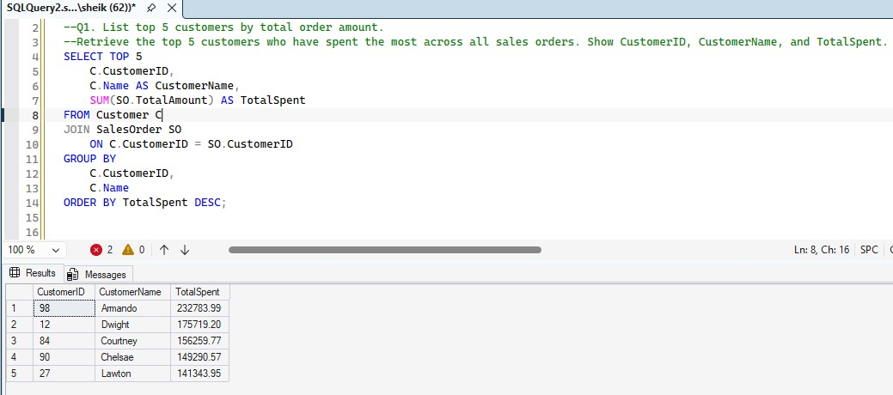

Q2. Find the number of products supplied by each supplier.
Display SupplierID, SupplierName, and ProductCount. Only include suppliers that have more than 10 products.
Qurey:
SELECT
S.SupplierID,
S.Name AS SupplierName,
COUNT(DISTINCT POD.ProductID) AS ProductCount
FROM Supplier S
JOIN PurchaseOrder PO
ON S.SupplierID = PO.SupplierID
JOIN PurchaseOrderDetail POD
ON PO.OrderID = POD.OrderID
GROUP BY
S.SupplierID,
S.Name
HAVING COUNT(DISTINCT POD.ProductID) > 10;
--ORDER BY ProductCount ASC;
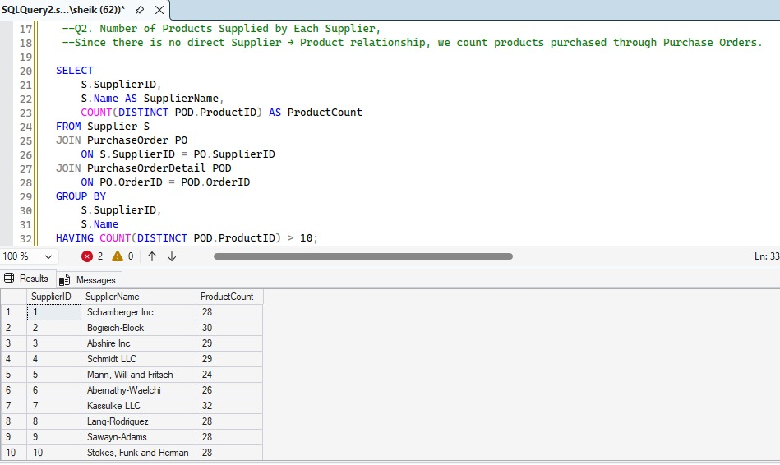

Q3. Identify products that have been ordered but never returned.
Show ProductID, ProductName, and total order quantity.
Sql code:
SELECT
P.ProductID,
P.Name AS ProductName,
SUM(SOD.Quantity) AS TotalOrderQuantity
FROM Product P
JOIN SalesOrderDetail SOD
ON P.ProductID = SOD.ProductID
WHERE P.ProductID NOT IN
(
SELECT ProductID
FROM ReturnDetail
)
GROUP BY
P.ProductID,
P.Name;
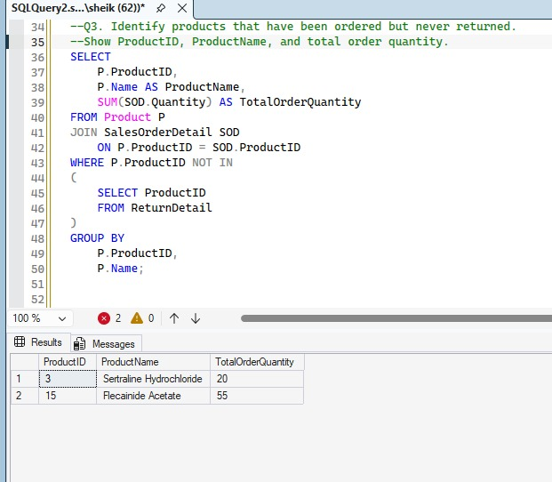

Q4. For each category, find the most expensive product.
Display CategoryID, CategoryName, ProductName, and Price. Use a subquery to get the max price per category.
Sql code:
SELECT
C.CategoryID,
C.Name AS CategoryName,
P.Name AS ProductName,
P.Price
FROM Product P
JOIN Category C
ON P.CategoryID = C.CategoryID
WHERE P.Price =
(
SELECT MAX(P2.Price)
FROM Product P2
WHERE P2.CategoryID = P.CategoryID
);
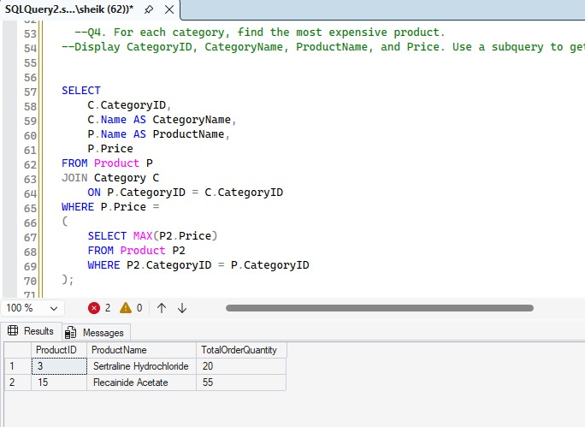
Q5. List all sales orders with customer name, product name, category, and supplier.
For each sales order, display:
OrderID, CustomerName, ProductName, CategoryName, SupplierName, and Quantity.
Sql code:
SELECT
SO.OrderID,
C.Name AS CustomerName,
P.Name AS ProductName,
CAT.Name AS CategoryName,
S.Name AS SupplierName,
SOD.Quantity
FROM SalesOrder SO
JOIN Customer C
ON SO.CustomerID = C.CustomerID
JOIN SalesOrderDetail SOD
ON SO.OrderID = SOD.OrderID
JOIN Product P
ON SOD.ProductID = P.ProductID
JOIN Category CAT
ON P.CategoryID = CAT.CategoryID
JOIN PurchaseOrderDetail POD
ON P.ProductID = POD.ProductID
JOIN PurchaseOrder PO
ON POD.OrderID = PO.OrderID
JOIN Supplier S
ON PO.SupplierID = S.SupplierID;
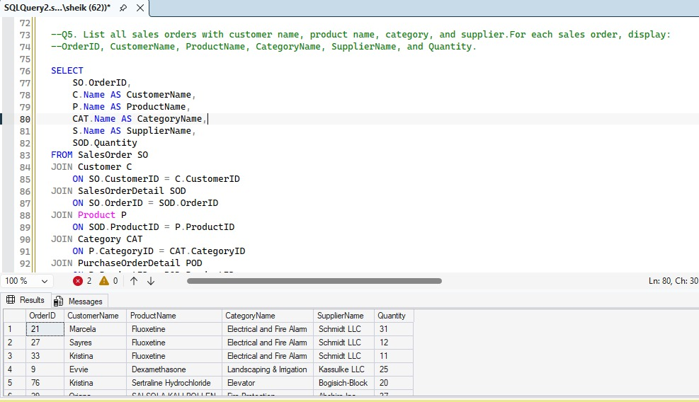

Q6. Find all shipments with details of warehouse, manager, and products shipped.
Display:
ShipmentID, WarehouseName, ManagerName, ProductName, QuantityShipped, and TrackingNumber.
Sql code:
SELECT
SH.ShipmentID,
L.Name AS WarehouseName,
E.Name AS ManagerName,
P.Name AS ProductName,
SD.Quantity AS QuantityShipped,
SH.TrackingNumber
FROM Shipment SH
JOIN Warehouse W
ON SH.WarehouseID = W.WarehouseID
LEFT JOIN Employee E
ON W.ManagerID = E.EmployeeID
LEFT JOIN Location L
ON W.LocationID = L.LocationID
JOIN ShipmentDetail SD
ON SH.ShipmentID = SD.ShipmentID
JOIN Product P
ON SD.ProductID = P.ProductID;
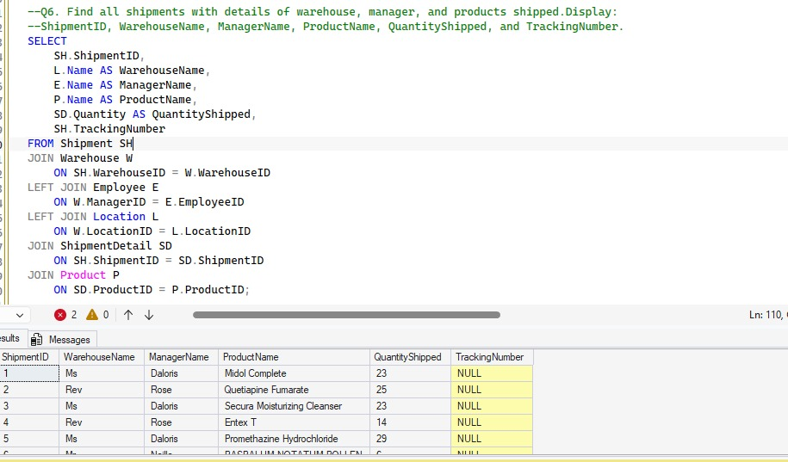

Q7. Find the top 3 highest-value orders per customer using RANK(). Display CustomerID, CustomerName, OrderID, and TotalAmount.
Sql code:
WITH CustomerOrderRank AS
(
SELECT
C.CustomerID,
C.Name AS CustomerName,
SO.OrderID,
SO.TotalAmount,
RANK() OVER
(
PARTITION BY C.CustomerID
ORDER BY SO.TotalAmount DESC
) AS OrderRank
FROM Customer C
JOIN SalesOrder SO
ON C.CustomerID = SO.CustomerID
)

SELECT
CustomerID,
CustomerName,
OrderID,
TotalAmount
FROM CustomerOrderRank
WHERE OrderRank <= 3
ORDER BY CustomerID, TotalAmount DESC;
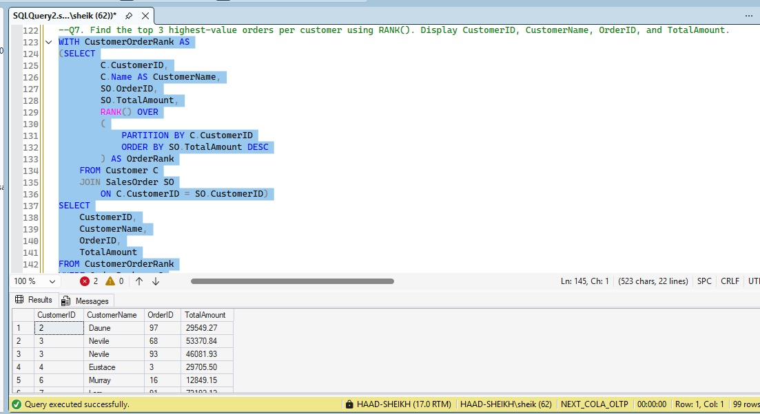

Q8. For each product, show its sales history with the previous and next sales quantities (based on order date). Display ProductID, ProductName, OrderID, OrderDate, Quantity, PrevQuantity, and NextQuantity.
Sql code:
SELECT
P.ProductID,
P.Name AS ProductName,
SO.OrderID,
SO.OrderDate,
SOD.Quantity,

LAG(SOD.Quantity)
OVER (
PARTITION BY P.ProductID
ORDER BY SO.OrderDate
) AS PrevQuantity,

LEAD(SOD.Quantity)
OVER (
PARTITION BY P.ProductID
ORDER BY SO.OrderDate
) AS NextQuantity

FROM Product P
JOIN SalesOrderDetail SOD
ON P.ProductID = SOD.ProductID
JOIN SalesOrder SO
ON SOD.OrderID = SO.OrderID
ORDER BY
P.ProductID,
SO.OrderDate;
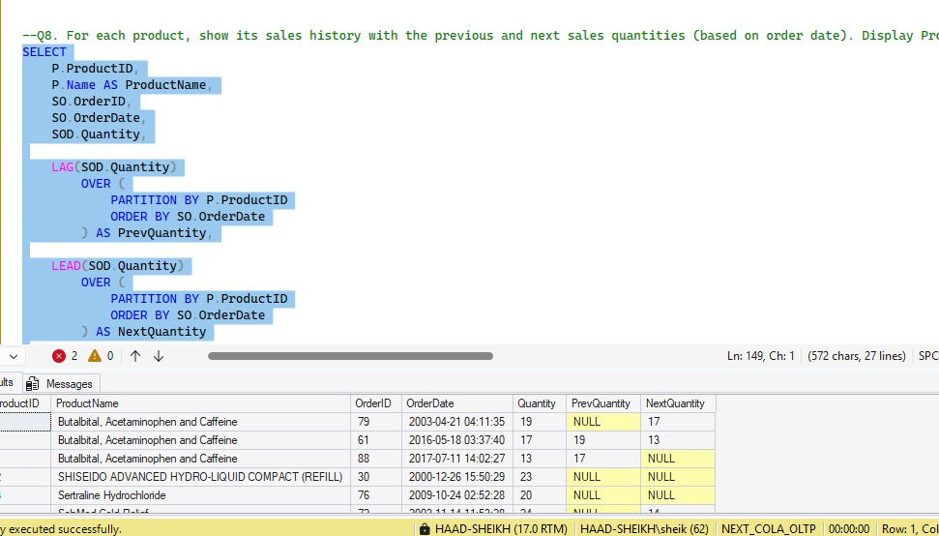
Q9. Create a view named vw_CustomerOrderSummary that shows for each customer:
CustomerID, CustomerName, TotalOrders, TotalAmountSpent, and LastOrderDate.
Sql code:
CREATE VIEW vw_CustomerOrderSummary
AS
SELECT
C.CustomerID,
C.Name AS CustomerName,
COUNT(SO.OrderID) AS TotalOrders,
SUM(SO.TotalAmount) AS TotalAmountSpent,
MAX(SO.OrderDate) AS LastOrderDate
FROM Customer C
LEFT JOIN SalesOrder SO
ON C.CustomerID = SO.CustomerID
GROUP BY
C.CustomerID,
C.Name;
GO

SELECT * FROM vw_CustomerOrderSummary;
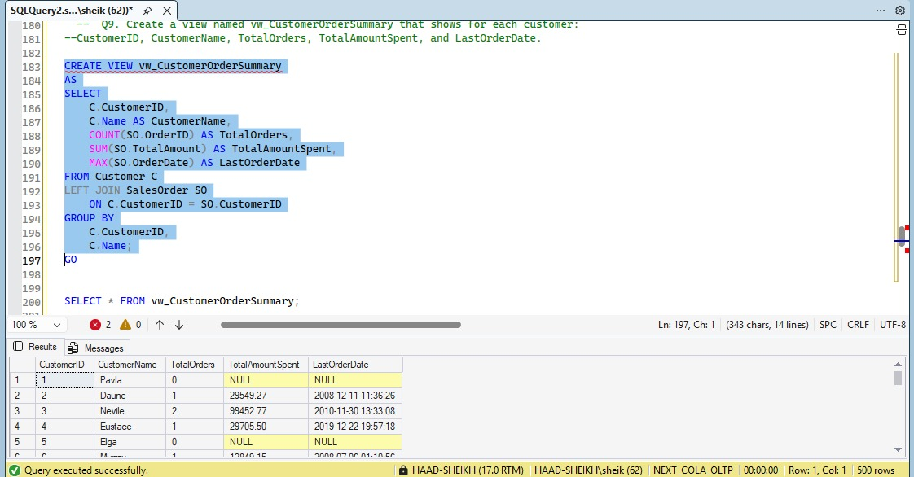

Q10. Write a stored procedure sp_GetSupplierSales that takes a SupplierID as input and returns the total sales amount for all products supplied by that supplier.
Sql code:
CREATE PROCEDURE sp_GetSupplierSales
@SupplierID INT
AS
BEGIN

SELECT
@SupplierID AS SupplierID,
S.Name AS SupplierName,
SUM(SOD.TotalAmount) AS TotalSalesAmount

FROM Supplier S

JOIN PurchaseOrder PO
ON S.SupplierID = PO.SupplierID

JOIN PurchaseOrderDetail POD
ON PO.OrderID = POD.OrderID

JOIN SalesOrderDetail SOD
ON POD.ProductID = SOD.ProductID

WHERE S.SupplierID = @SupplierID

GROUP BY
S.Name;

END
GO
EXEC sp_GetSupplierSales @SupplierID = 1;
